

**FINAL PROJECT**

**On**

**BookBiz Management System**

**Submitted to**

**Alex Vilvert**

**By**

**Rahul Pipaliya(2012728)**

Contents

Project Description 3

Interface Design 4

1)Login Page 4

2)Employee Management Form 5

3)Sales Manager Form 6

4)Inventory Management Form 7

5)Order Management Form 8

Code Design 9

1)Project Structure 9

2)Database Design 10

Implementation 12

1)Validations 12

2)Operations 14

Conclusion 19

# Project Description

* This Project Aims to Create a Software in C# to help **BookBiz Distribution Inc.** to supply computer science books nearly all Quebec Universities and in colleges using a Windows based application **BookBiz Management System**.
* Currently in system we have 5 users and 4 user roles

1. MIS Manager
2. Sales Manager
3. Inventory Controller
4. Order Clerk

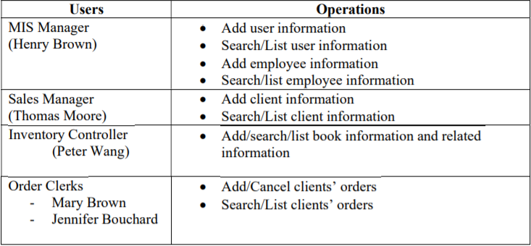

## Interface Design

### 1)Login Page

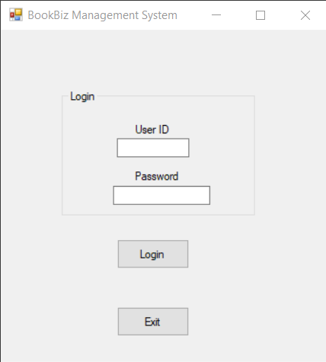

The first form user will be seeing is this login page. I have already set userid , password for above mentioned users. Each login will redirect to company’s Employee/User to their Department Page.

Eg. Login of henry brown will be redirected to Employee Management Form…etc.

Id/passwords:

|  |  |  |
| --- | --- | --- |
| Id | Password | Roles |
| henryb | henryb123 | MIS Manager |
| thomasm1 | thomas123 | Sales Manager |
| peter123 | peter123 | Inventory Controller |
| maryb1 | 12345 | Order Clerk |
| jennibo1 | 12345 | Order Clerk |

### 2)Employee Management Form

Using credentials of Henry Brown, you shall see this form.

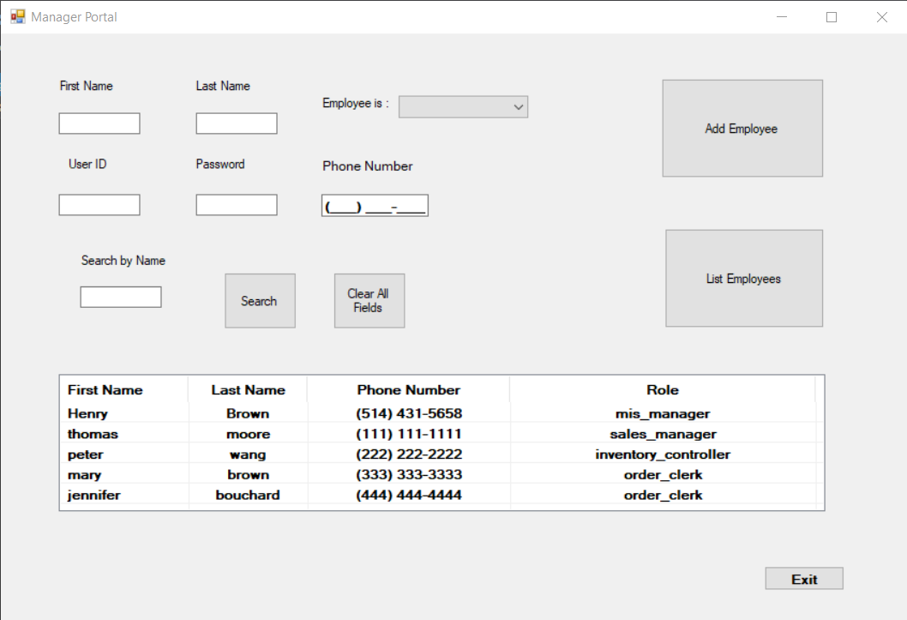

Here, Managers Functionalities are.

1. Add new employees’ information
2. assign userid and password to the employees
3. search employees using their name
4. view list of currently working Employees/users in the organization

### 3)Sales Manager Form

Using credentials of Thomas Moore, you shall see this form.

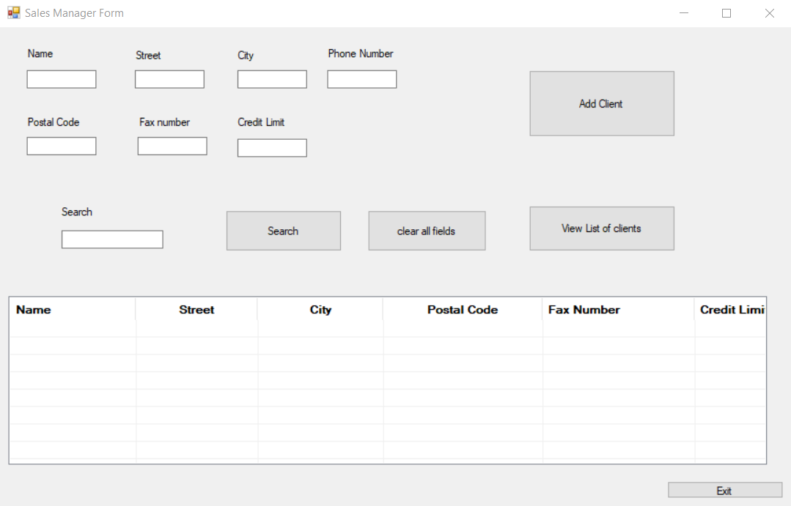

Here, Sales Manager can,

1. Add client’s information
2. View organizations current clients
3. Search clients

### 4)Inventory Management Form

credentials of peter wang shall redirect you to this form.

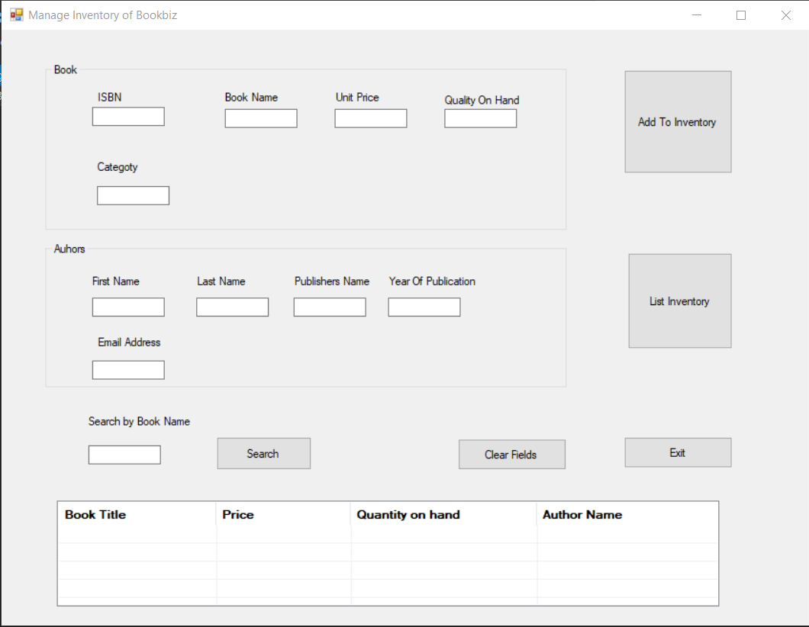

Using this System Inventory Manager can..

1. Add Books Info
2. Add Author as well as Publishers info
3. View book information including current quantity on hand
4. Search book by name

### 5)Order Management Form

Using id/password of Mary Brown/ Jennifer Bouchard will lead you to this form

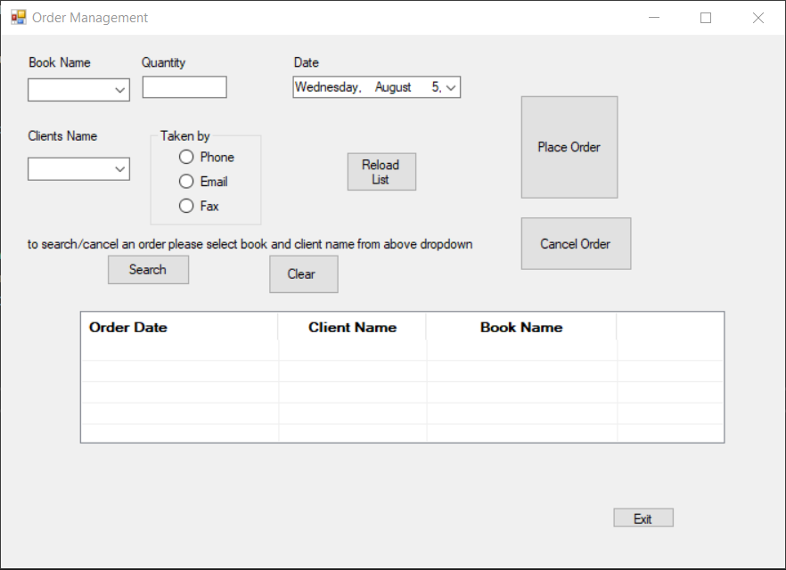

Using this form order clerk will be able to...

1. Add Clients Orders
2. View Clients Orders
3. Cancel Clients Orders
4. Search Clients Orders using Client Name and Book Name combined.

## Code Design

### 1)Project Structure

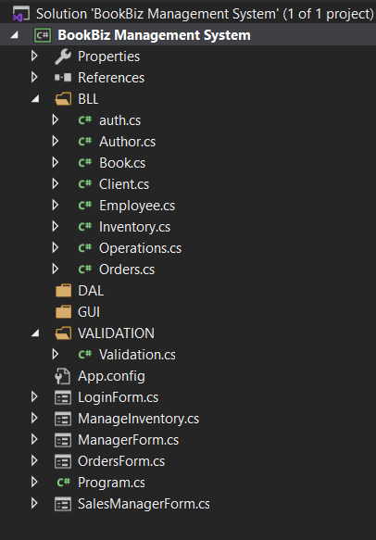

* All the classes, Database Operations are in the BLL.

* Validations are in VALIDATION

* Unfortunately, I could not place all the forms in GUI Folder it was not accessible for some reason. So, its outside but accessible.

### 2)Database Design

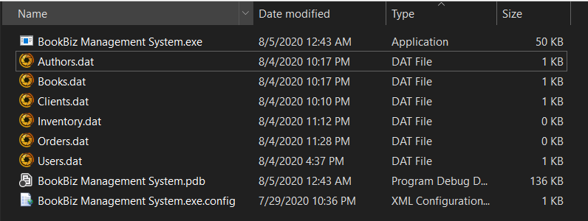

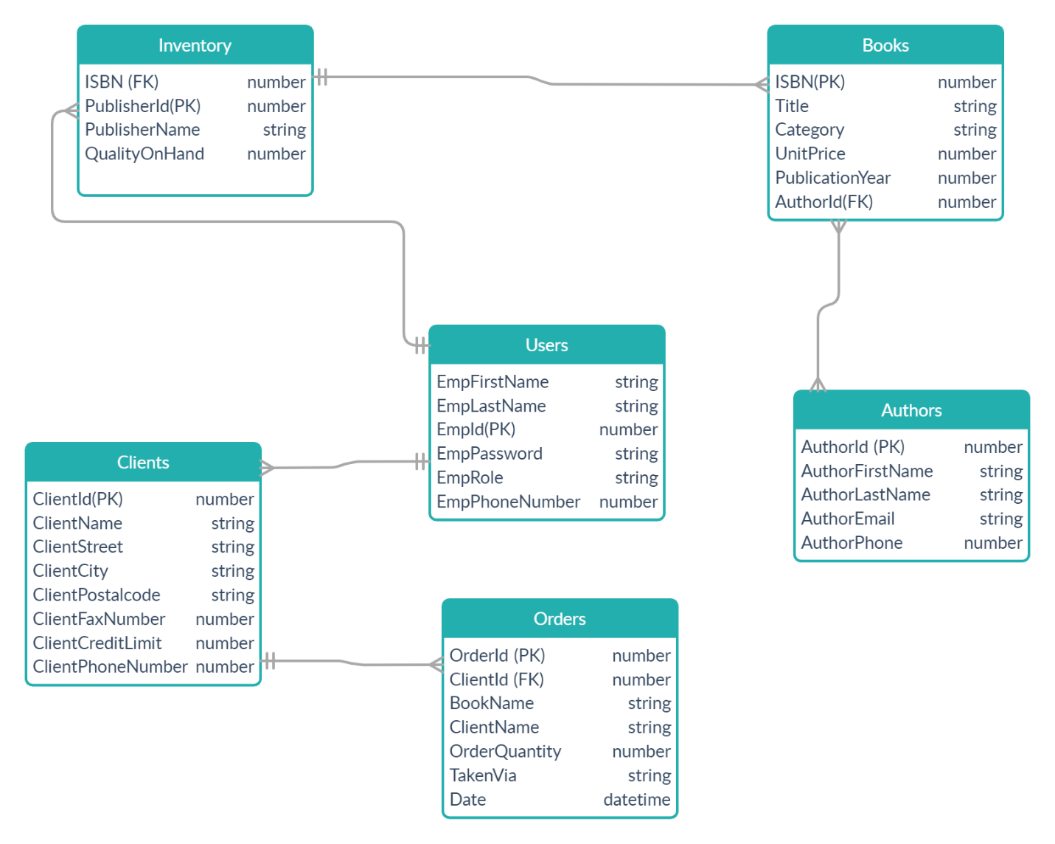

## Implementation

Source Code : https://github.com/HoruScodes/bookbiz-management-system.git

Almost all the methods are the same.

I have implemented Validations and Operations.

### 1)Validations

#### a) Email Validation

I have used Regex to validate emails.



#### b) Number Validation and Phone Number/Fax Number validations





Code reuse in function isValidContactNumber

#### c)Name Validations



### 2)Operations

#### a)List Contents



I have written almost similar functions to list contents so I won’t be posting all the code

Steps are.

=>Read the file

=>Read the lines and split lines by commas and store into strings[] array

=>Set the items using item.SubItems.Add()

=>Run the loop until End of file.

#### b)Add to Database

by far this was little complex for me as I was adding to 3 databases (Author , Books ,

Inventory) at once in inventory form.

Also I had to generate authorId , publisherid , it was little complex for me but I think I

Came with good solution..

=>real the database file

=>get the last line of file if its empty then set id to 0 else get the last lines id and return new id = id + 1;



And To add Data to Database..



#### c)search in the database

=>Read the file

=> Read the file

=>Read the lines and split lines by commas and store into strings [] array

=>Search if item == fields []

=>if yes then add that line to item.SubItems.Add() and then show it in the listviewbox

In form.



Here I have searched for specific order using bookname and client name.

#### d)removing a record.



Creating a new file and saving the all the data excluding specific line and replace/set

That file as new database will do the work. That is what I have done.

# Conclusion

the most important is that it is not about technology or creating a good project plan

Ability to see the big picture of the project and focus on particular details when needed deserves a second place in my list. For each project this "details" level would be different, but the key is the ability to shift your focus.

Proactivity would go to the third place. A good Developer should not wait for something to happen - he/she needs to anticipate things and constantly look for ways to make the project better. It may be a friendly reminder of something you agreed with your client verification of assumptions or risk mitigation steps, but it saves a lot of trouble and delays on most projects.

On a technical side , This project allowed me to use and test the many software development methods learned during the classes in ADOBE CONNECT. The Project had consisted of a set of tasks that requires validations and system requirements from users. using classes, we can see how could be easy to implement and also reuse. Last 3 lectures helped me so much.

Thank you alex for teaching me , it is my honor to be your student.